**Amazon WS**

# Steps to be follow:

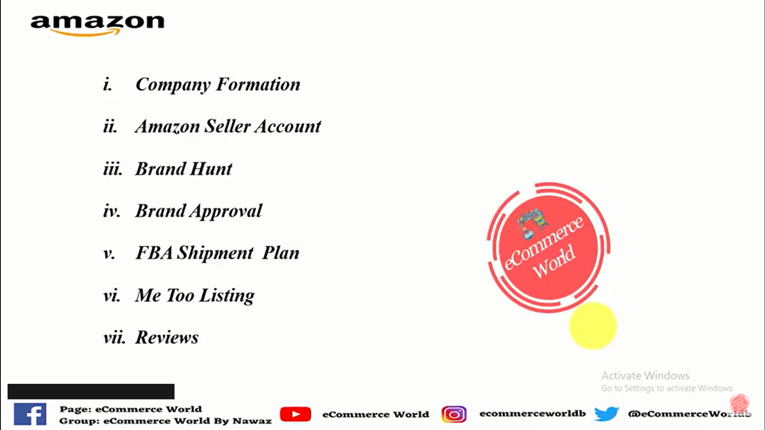

# Company formation:

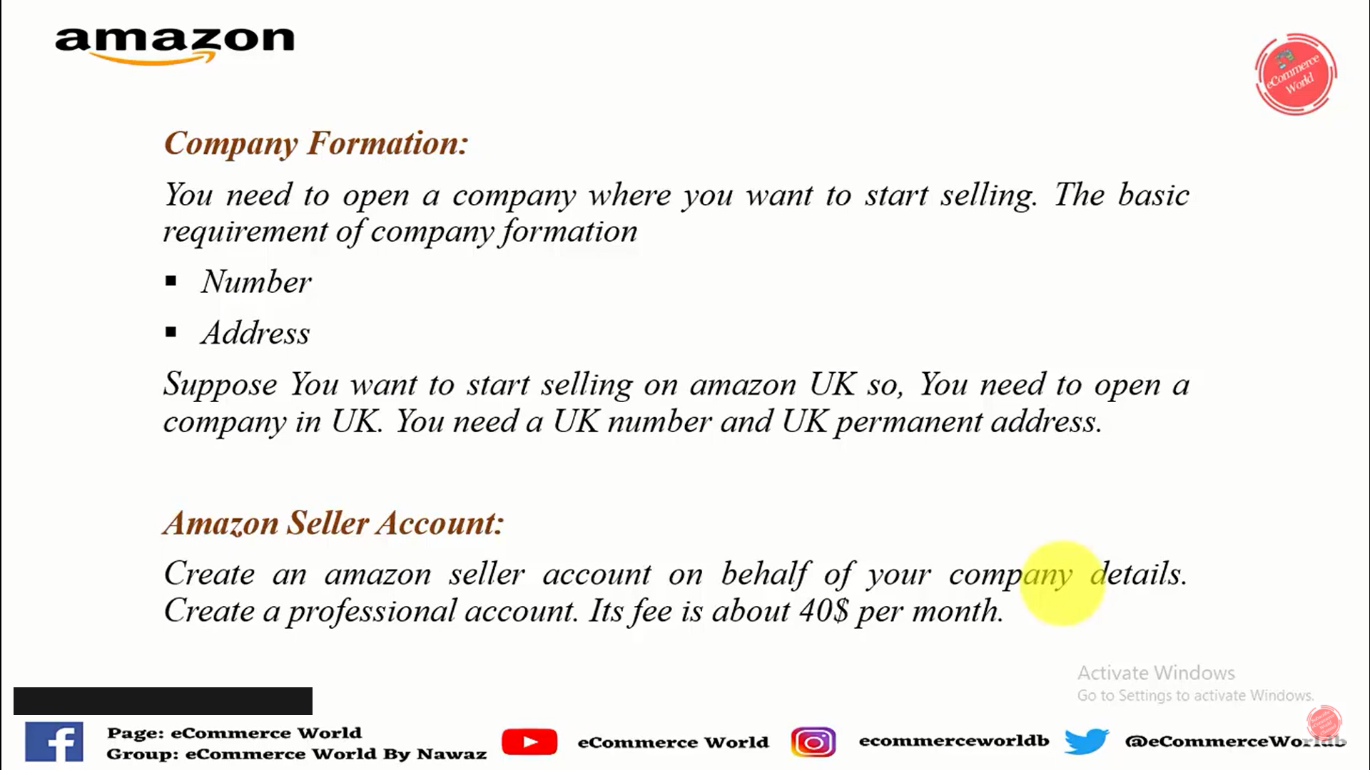

# Listing checking:

* Sign of interrogation should be green in front of brand name
* Should not be the brand of product in competition
* Should not amazon in competition
* Should not be more than 2 FBA seller

# What is LLC?

Extenmions:

Ds amazon quick view

Daps: